Course Name: | EEEE | Semester: | I/II
Date of Performance: | 30/11/2021 | Batch No: | A2
Faculty Name: | Maruti Zalte | Roll No: | 16010121045
Faculty Sign & Date: |  | Grade/Marks:

Experiment No: 5
Title: Mobile Battery Charger

Aim and Objective of the Experiment:
- To understand the working of Mobile Battery Charging Circuit
- To implement the circuit of Mobile Battery charger on Breadboard and observe the waveforms at various points (Input and output Waveforms for Bridge Rectifier) and measure the output voltage

Requirements:
Step-down Transformer (+/- 12 V), Diodes(1N4007), voltage regulator IC 7805, Resistor, Capacitors((1000µF, 100µF, 10µF,0.01 µF ), CRO, Digital Multimeter (DMM), breadboard, connecting wires, Micro USB cable, etc.

Theory:
A rectifier is an electrical device that converts alternating current (AC), which periodically reverses direction, to direct current (DC), which flows in only one direction. Depending on the type of alternating current supply and the arrangement of the rectifier circuit, the output voltage may require additional smoothing to produce a uniform steady voltage.
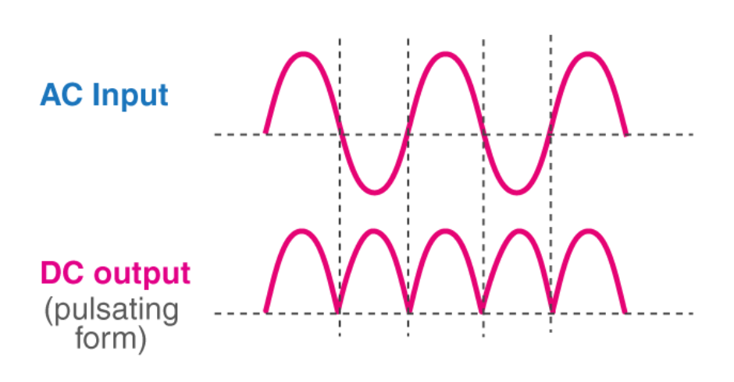
Among the rectifiers, the bridge rectifier is the most efficient rectifier circuit. A diode bridge is an arrangement of four diodes in a bridge circuit configuration that provides the same polarity of output for either polarity of input. A bridge rectifier allows electric current during both positive and negative half cycles of the input AC signal. The output waveforms of the bridge rectifier are shown in the below figure.
Bridge Rectifier
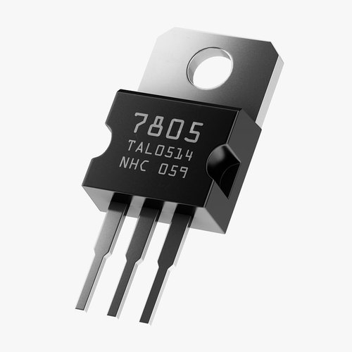
A voltage regulator is a system designed to automatically maintain a constant voltage. A voltage regulator may use a simple feed-forward design or may include negative feedback. It may use an electromechanical mechanism, or electronic components. Depending on the design, it may be used to regulate one or more AC or DC voltages.
7805 Voltage Regulator

Circuit Diagram/ Block Diagram:
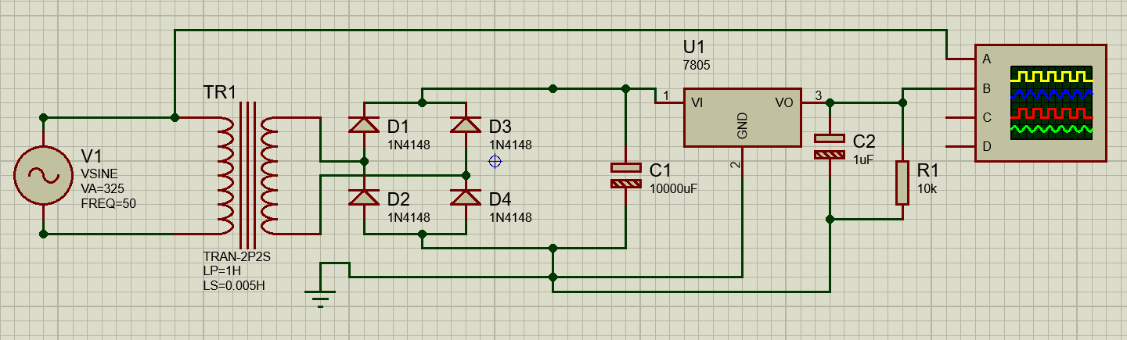

Stepwise-Procedure:
- Design circuit and connect it as shown in the circuit diagram using Proteus simulator.
- Run the hardware and take scree shot of it to attach in the output.

Output waveforms observed on CRO:

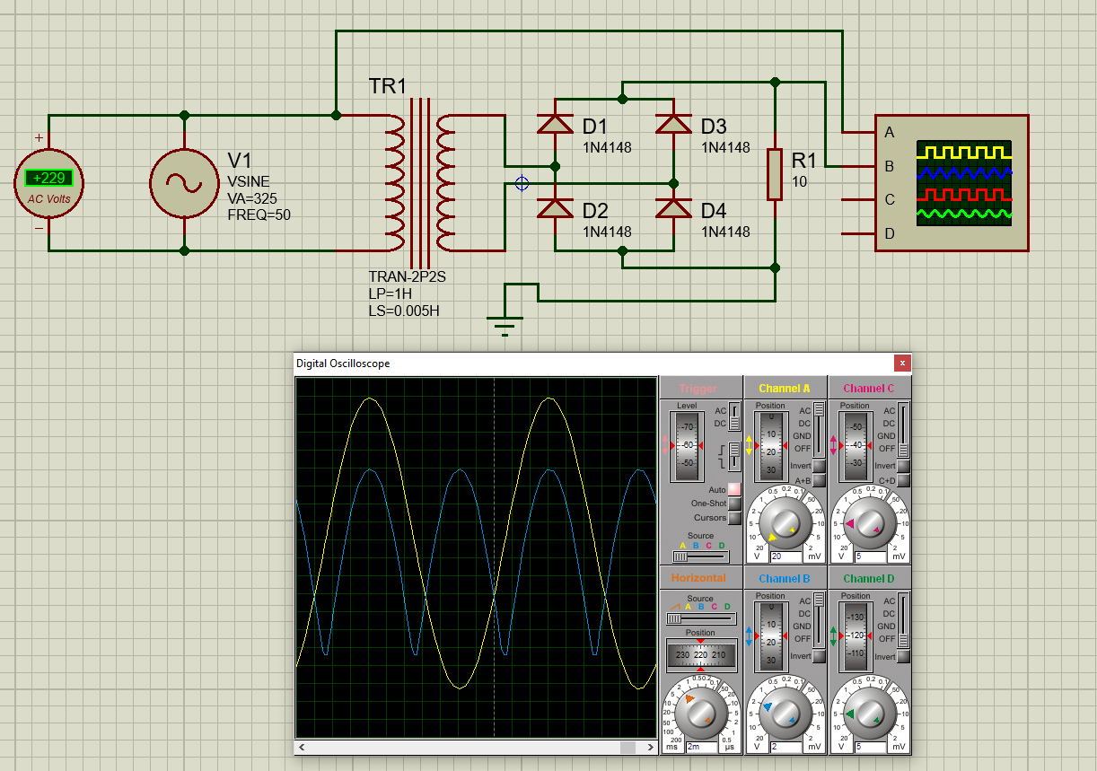

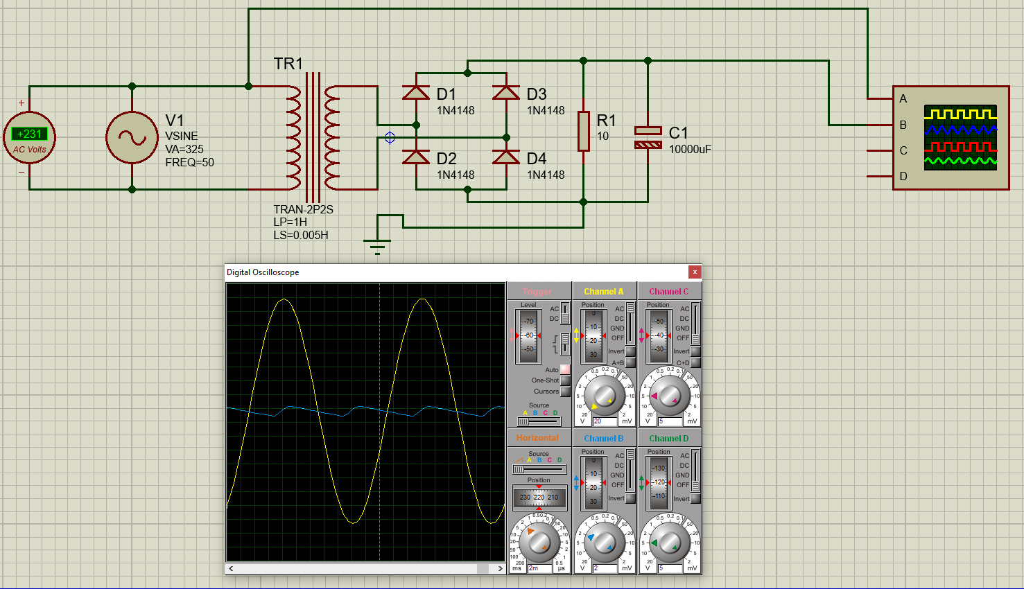

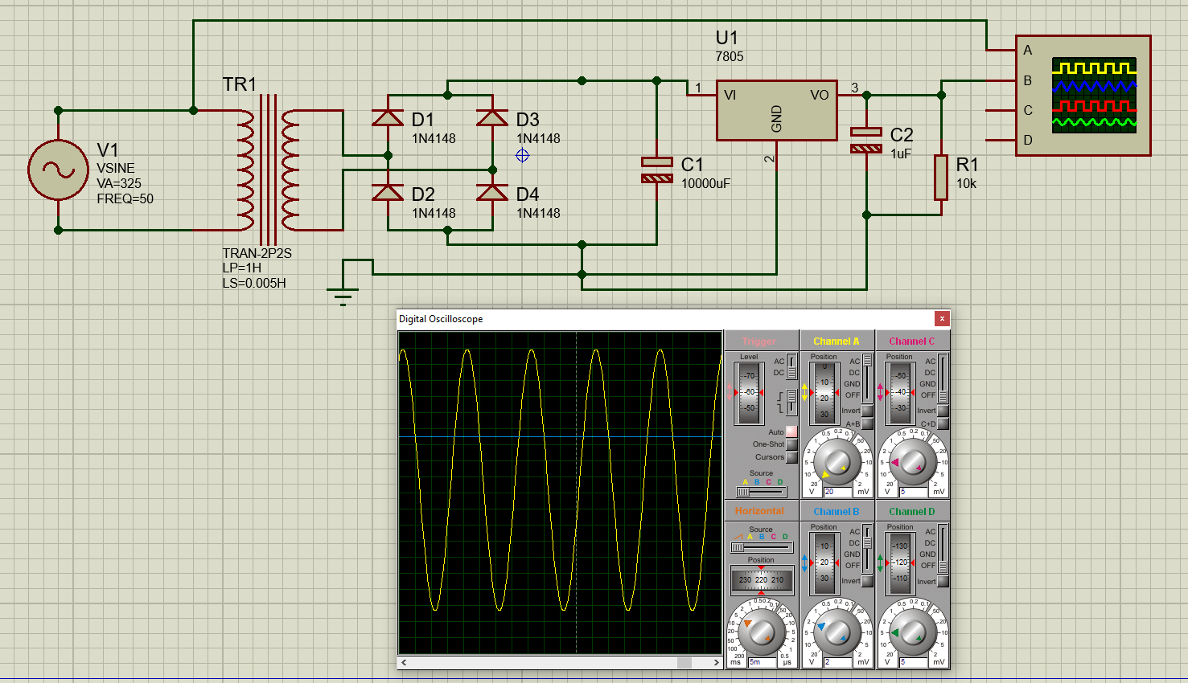

Observation Table:
Vin(p-p )  (input of Rectifier in Volts) | Vout(peak)  Output of Rectifier (in Volts) | DC output of Charger (in Volts)
45.68 V | 20.16 V | 5 V

Post Lab Subjective/Objective type Questions:
1. Explain working of Mobile Battery charger circuit.

For the reason of smaller in size, the mobile charger has a different charging circuit than a normal battery charger circuit.
- At first, the 220-230V AC supply passes through the bridge rectifier which made by four diodes and then it rectified by the bridge rectifier.
- The DC output is filtrated by a capacitor.
- Then 220-230V DC passing through the two transistors and being converted into a high-frequency AC signal.
- The high-frequency AC signals again passing through capacitors for power factor correction and filter which increases the efficiency of the circuit.
- Then the filtrate high-frequency AC signal goes to the pulse transformer which steps down the voltage to 5V.
- The 5v AC is converted to DC by a diode.
- The DC output is filtrated by a capacitor.
Then the pure DC is supplied to mobile for charge the battery.

2. Explain the working principle of Turbo- charger for mobile phones .

A Turbo Charger communicates with the phone to know some details about battery, temperature and compatibility. It then provides more voltage and current to the phone after calculating some facts. It checks for the temperature and battery charging percentage to change voltage and current whenever required. A turbo charger provides charging to phone at high pace and adjusts its pace as per the conditions of phone and its battery. The power provided here changes as per the situation.
Turbo charging allows you to dump a lot of power into your battery by using higher-than-normal voltage until it reaches what's called "saturation" - usually around 60-80% charge depending on how the phone's power management is configured. At that point, the phone's power controller scales back the amount of power it's receiving and your phone will begin to charge more and more slowly as it approaches 100%. Turbo charging allows your phone to intelligently scale the amount of power it takes from the charger based on the current charge state of the battery.

3. State commonly used types of mobile phone batteries.

There are two very commonly used types of batteries used in modern cell phones- Lithium Polymer and Lithium Ion.
Lithium-ion batteries are found not just on smartphones but on laptops, PDAs, cars, and iPods. Most smartphone brands including Samsung, iPhone, Infinix, Nokia use lithium-ion batteries. Lithium Polymer batteries are used in most modern gadgets and most of the new flagship devices.

4. Explain how to maximize Battery Performance/ Battery life of your mobile phone?

The battery life of a mobile phone can be maximised as follows-
- Phones should be kept out of direct sunlight for prolonged periods, especially in summer when surface temperatures can increase to above 70℃.
- The easiest way to conserve battery life while maintaining full function is to reduce the brightness of the screen. For devices that have an organic light emitting diode (OLED) display, you can also use the “light on dark” option for viewing.
- To maximize the battery capacity in the future we should avoid that 0% battery mark altogether, while also keeping those batteries at least partially charged if storing them for a prolonged period of time to avoid deep discharge.
- Charging at lower rates allows more complete shuttling to occur, which enhances the battery’s charge capacity. Therefore, charging up your phone in that 30% to 80% range keeps the voltage lower and might slightly prolong the battery’s lifespan.
- Use Airplane Mode. When turning off all such auxiliary functions due to this mode, the device will use only up to 5% of its usual energy consumption with the screen off. For comparison, simply having your device in idle can still use more than 15%.
- Avoid charging overnight or in a cradle during the day because continuous trickle charging of a full battery can cause plating of the metallic lithium, which reduces stability in the long term and can, in rare cases, lead to system-wide malfunctions and reboots. Secondly, it leaves the battery at a higher stress voltage when at 100%. Third, and most important, it creates excess heat caused by wasted power dissipation.

5. Write important specifications of Voltage regulator IC 7805.

Important specification of Voltage regulator IC 7805 are-
- 5V Positive Voltage Regulator to power microcontrollers and sensors in most of the projects.
- Minimum Input Voltage is 7V.
- Maximum Input Voltage is 25V.
- Operating current(IQ) is 5mA.
- Internal Thermal Overload and Short circuit current limiting protection is available.
- Junction Temperature maximum 125 degree Celsius.
- Available in TO-220 and KTE package.
- Adjustable Output Regulator.
- Regulated Dual Supply. Output Polarity-Reversal-Protection Circuit

Conclusion:
This experiment taught us how to implement the circuit of a mobile battery charger by meticulously observing the waveforms at different points. Output voltage was calculated after the correct implementation of circuit. We also learned about the working of the mobile battery charger.

Signature of faculty in-charge with Date:

